201
9
Order Form
Your clients can purchase
Intuit QuickBooks 201
9

products at reduced prices. Please note, Intuit will discontinue version
201
6
in May 201
9
Referring
Firm CAN:

Referring Accounting Firm:
Referring Accountant & Email:
CLIENT INFO:
Contact Name: Phone:
Company Name: Email:
Address (No P.O. Boxes): City,State,Zip:
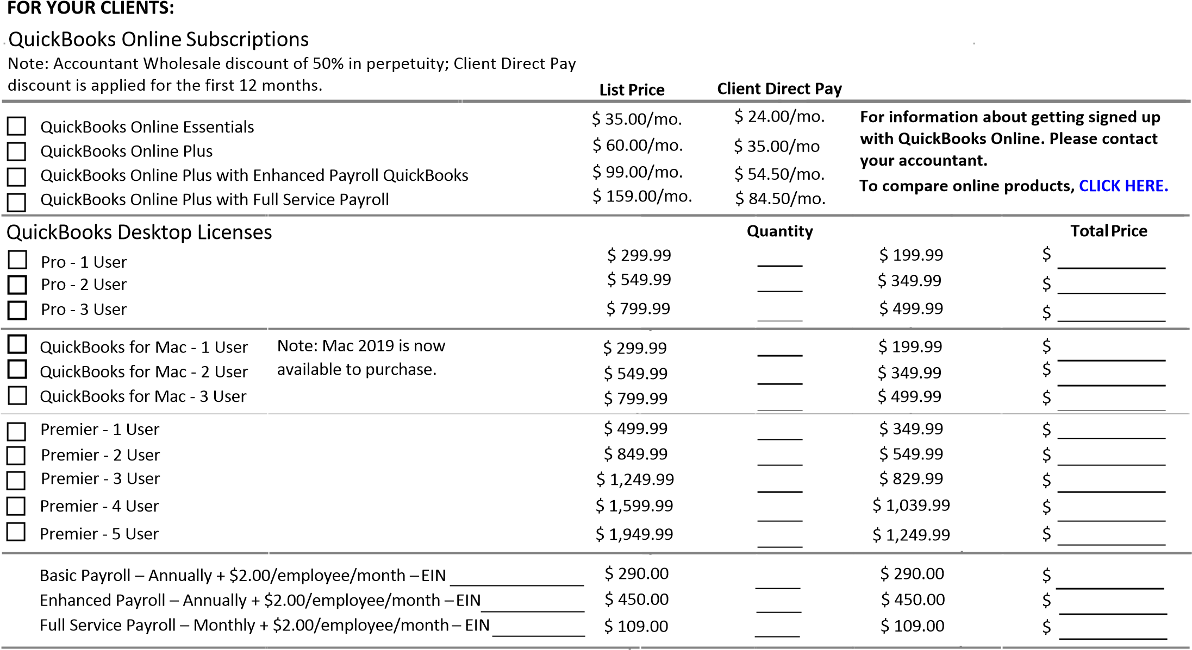
FOR YOUR FIRM : Version Protection, Accountant Copy File Transfer, and Client Collaborator Tool. Subscriptions run for 1 year, and software does not expire.
Accountants Edition – Email or call for quantity specific discounts
$
$
$
$
$
ProAdvisor Deluxe - Accountants Edition $ 349.00
ProAdvisor Deluxe with Accountant Payroll - Accountants Edition & Payroll $ 619.00
ProAdvisor Premier – Accountants, Enterprise, POS, Mac Editions $ 549.00
ProAdvisor Premier with Accountant Payroll – Accountants, Enterprise, POS, Mac Editions & Payroll $ 819.00
Enhanced Accountant Payroll - Annually Renewed $ 615.00
Choose a payment method below: Grand Total (Applicable Sales Tax will be added) $
Is the form of payment already on file? Yes No Firm or client credit card? Firm Client
If Yes, please provide last 4 digits of credit card and current expiration date below.
Last 4 Digits Expiration Date
If No, please provide a good call back number for us to reach you at below.
Contact Name Call Back Number
For a more detailed comparison chart of Enterprise options please click here
Enterprise Annual Subscription
Users |  | Silver E | dition | X | Gold Edition | X | Platinum Edition |  | Accountant Edition | X
 |  |  |  |  |  |  |  | X
 |  | Annual | Price |  | Annual Price |  | Annual Price |  | Annual Price
1 user | $1,100 / $880 |  |  |  | $1,430 / $1144 |  | $1,76 $1408 |  | / $1,16
2 user | $1,760 / $1408 |  |  |  | $2,090 / $1672 |  | $2,420 / $1936 |  | / $1
3 user | $2,200 / $1760 |  |  |  | $2,530 / $2024 |  | $2,860 / $2288 |  | / $
4 user | $2,640 / $2112 |  |  |  | $2,970 / $2376 |  | $3,300 / $2640 |  | / $20
5 user | $3,080 / $2464 |  |  |  | $3,410 / $2728 |  | $3,740 / $2992 |  | / $2
6 user | $3,410 / $2728 |  |  |  | $3,740 / $2992 |  | $4,070 / $3256 |  | / $
7 user | $3,740 / $2992 |  |  |  | $4,070 / $3256 |  | $4,400 / $3520 |  | / $30
8 user | $4,070 / $3256 |  |  |  | $4,400 / $3520 |  | $4,730 / $3784 |  | / $3
9 user | $4,400 / $3520 |  |  |  | $4,730 / $3784 |  | $5,060 / $4048 |  | / $
10 user | $4,730 / $3784 |  |  |  | $5,060 / $4048 |  | $5,390 / $4312 |  | / $
30 user | $6,930 / $6063.75 |  |  |  | $7,260 / $6352.50 |  | $7,590 / $6641.25 |  | $,0 / $
 | The Full Service Plan provides exclusive  benefits such as U.S.-  based customer support, the latest product  upgrades, online backup  storage, and our all-new  Advanced Reporting |  |  |  | Full Service Plan PLUS  QuickBooks Enhanced  Payroll for unlimited employees - no monthly fees. This level allow you to easily pay  employees, pay and file taxes. |  | Full Service Plan PLUS  QuickBooks Enhanced  Payroll PLUS Advanced  Inventory and Advanced  Pricing  (advantageous for manufacturers,  wholesalers, contractors, and retailers.)
For the product to remain active, The Enterprise subscription must be renewed annually.

